Lab Assignment #5: File System Management & Encryption

-Add a new (virtual SATA/IDE) hard drive to your CentOS VM

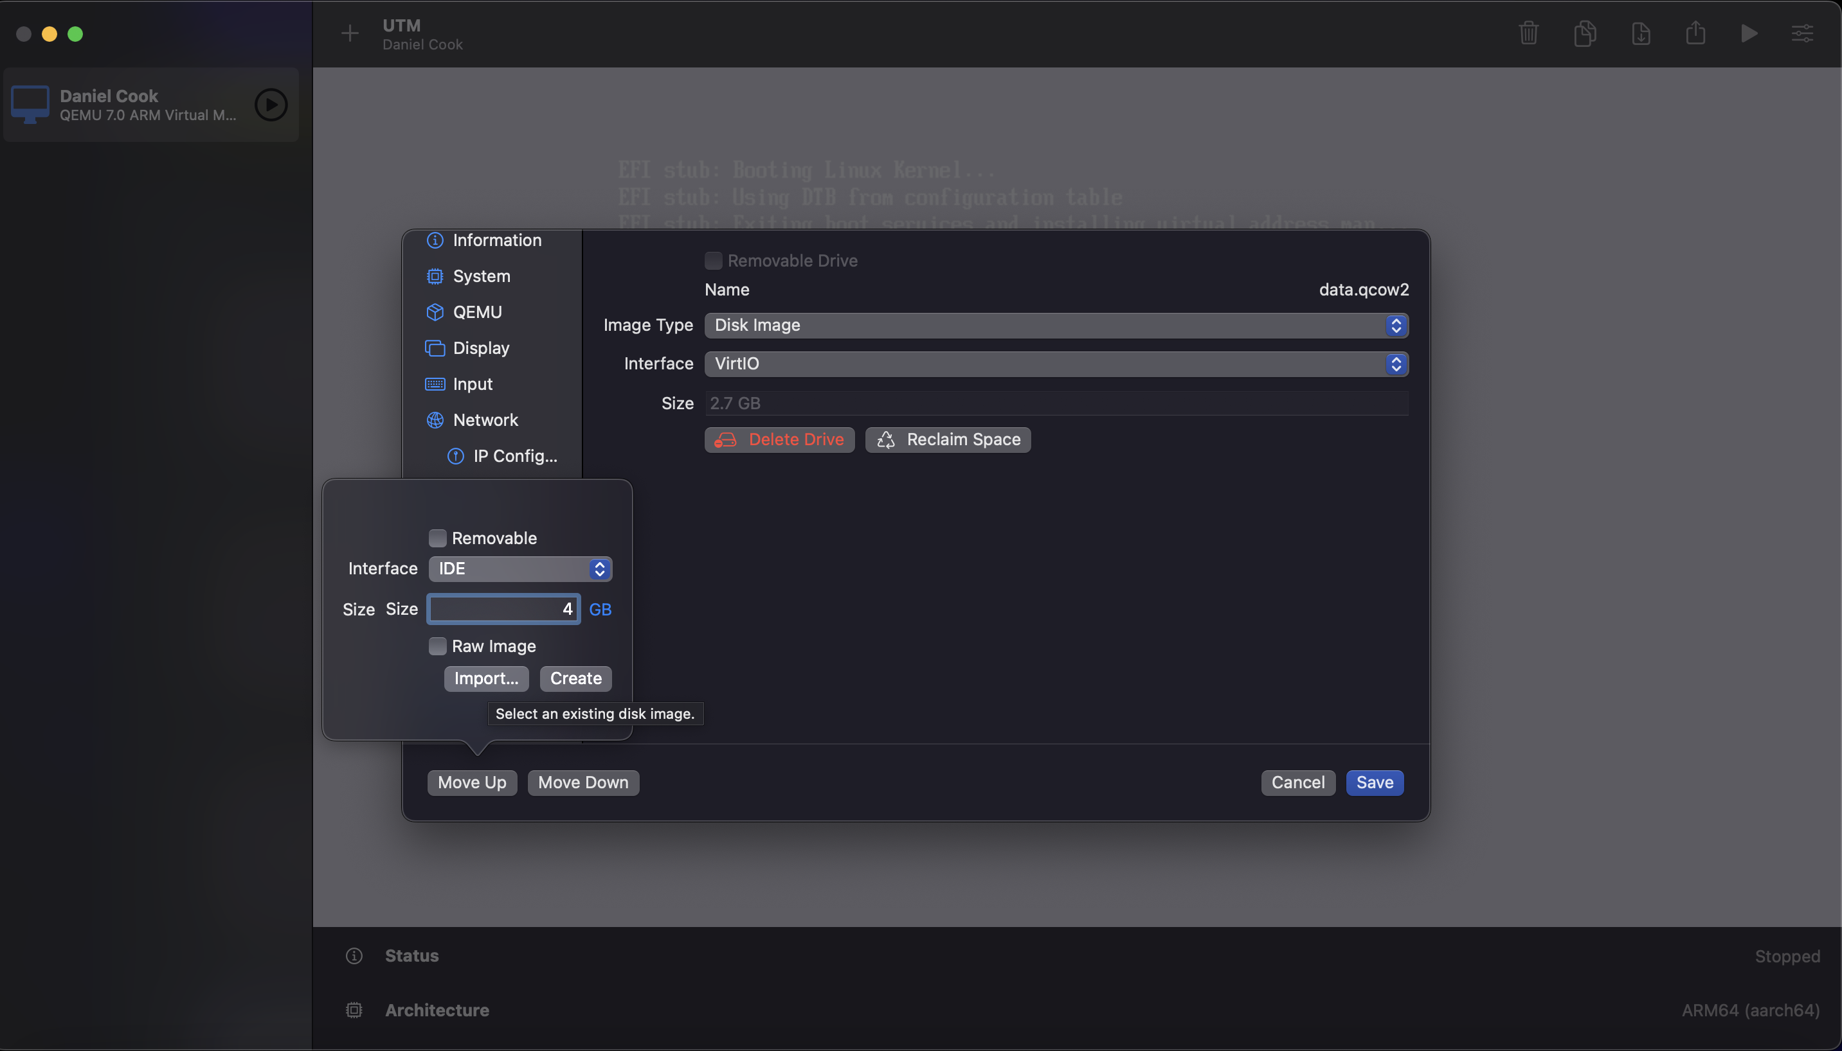

- Partition the new hard drive

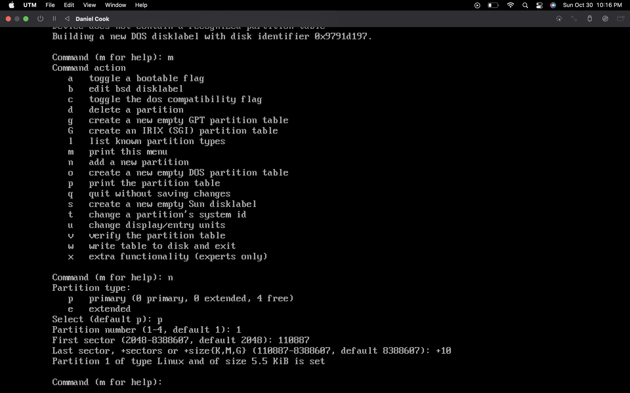

-Convert the partition that you want to add to the root volume to a Physical Volume

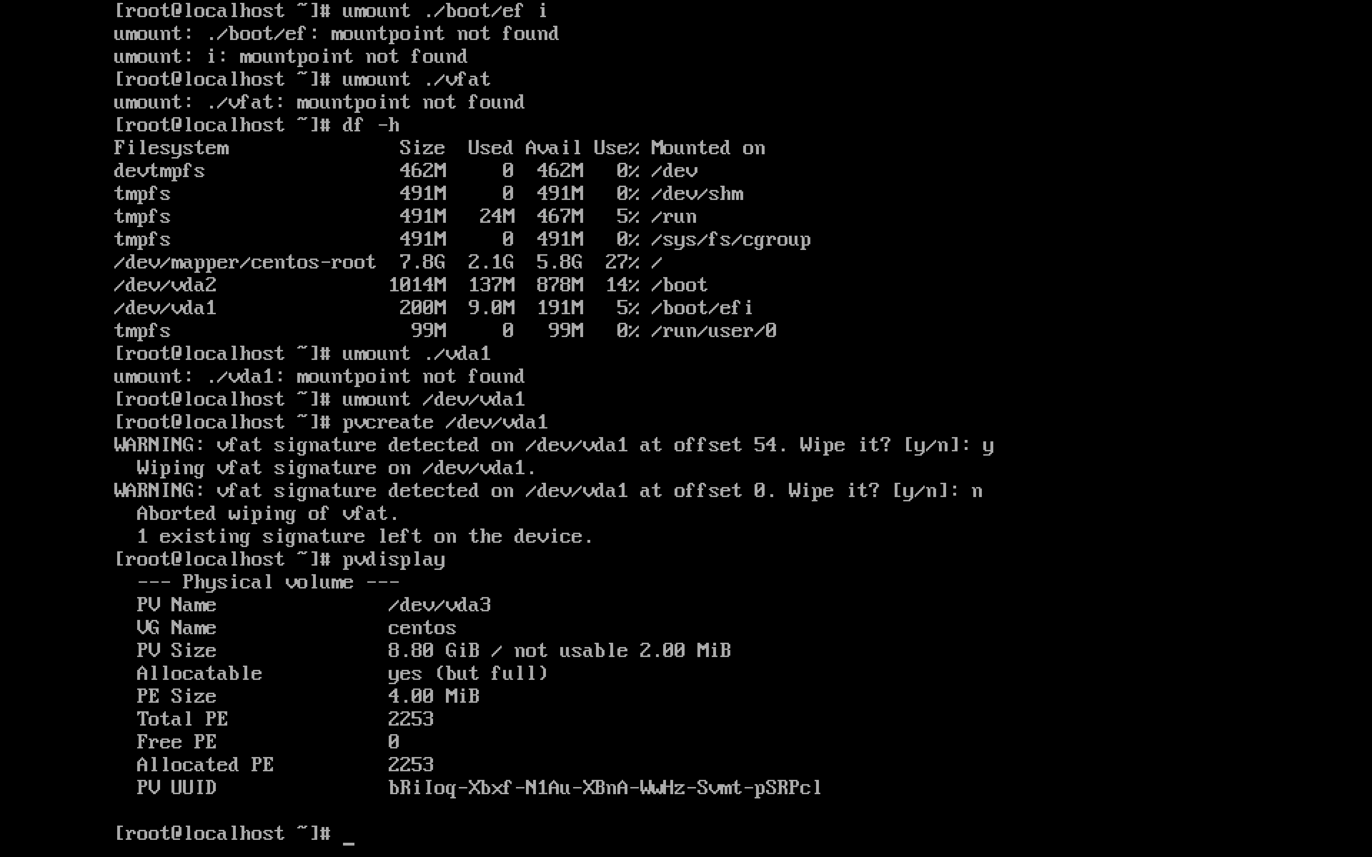

- Add the PV to the ‘centos’ Volume Group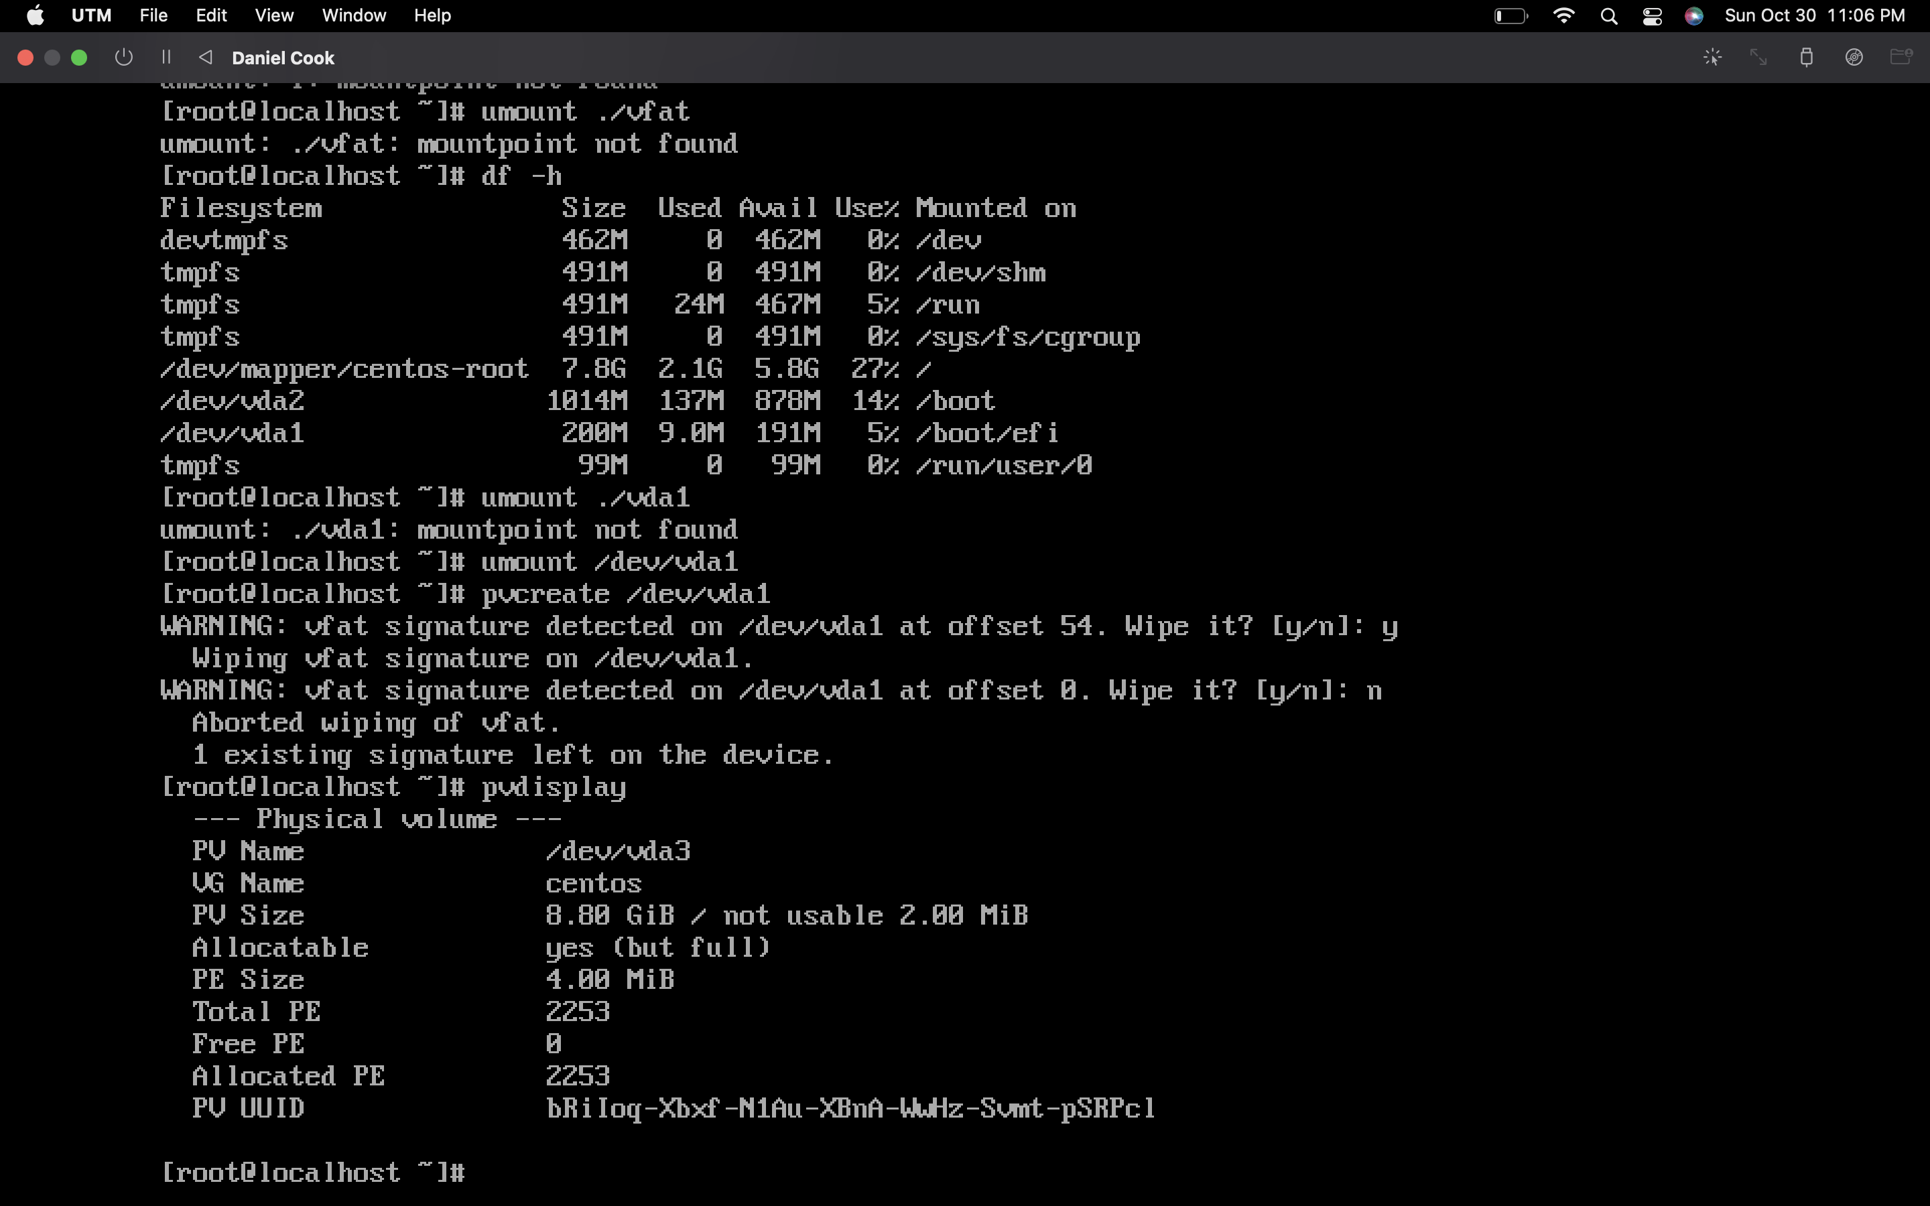

- Extend the ‘root’ LV (Logical Volume)

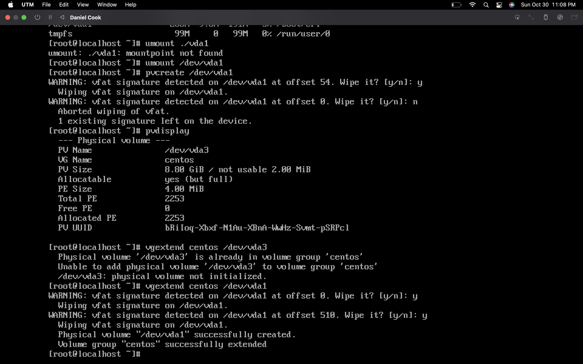

-Install LUKS

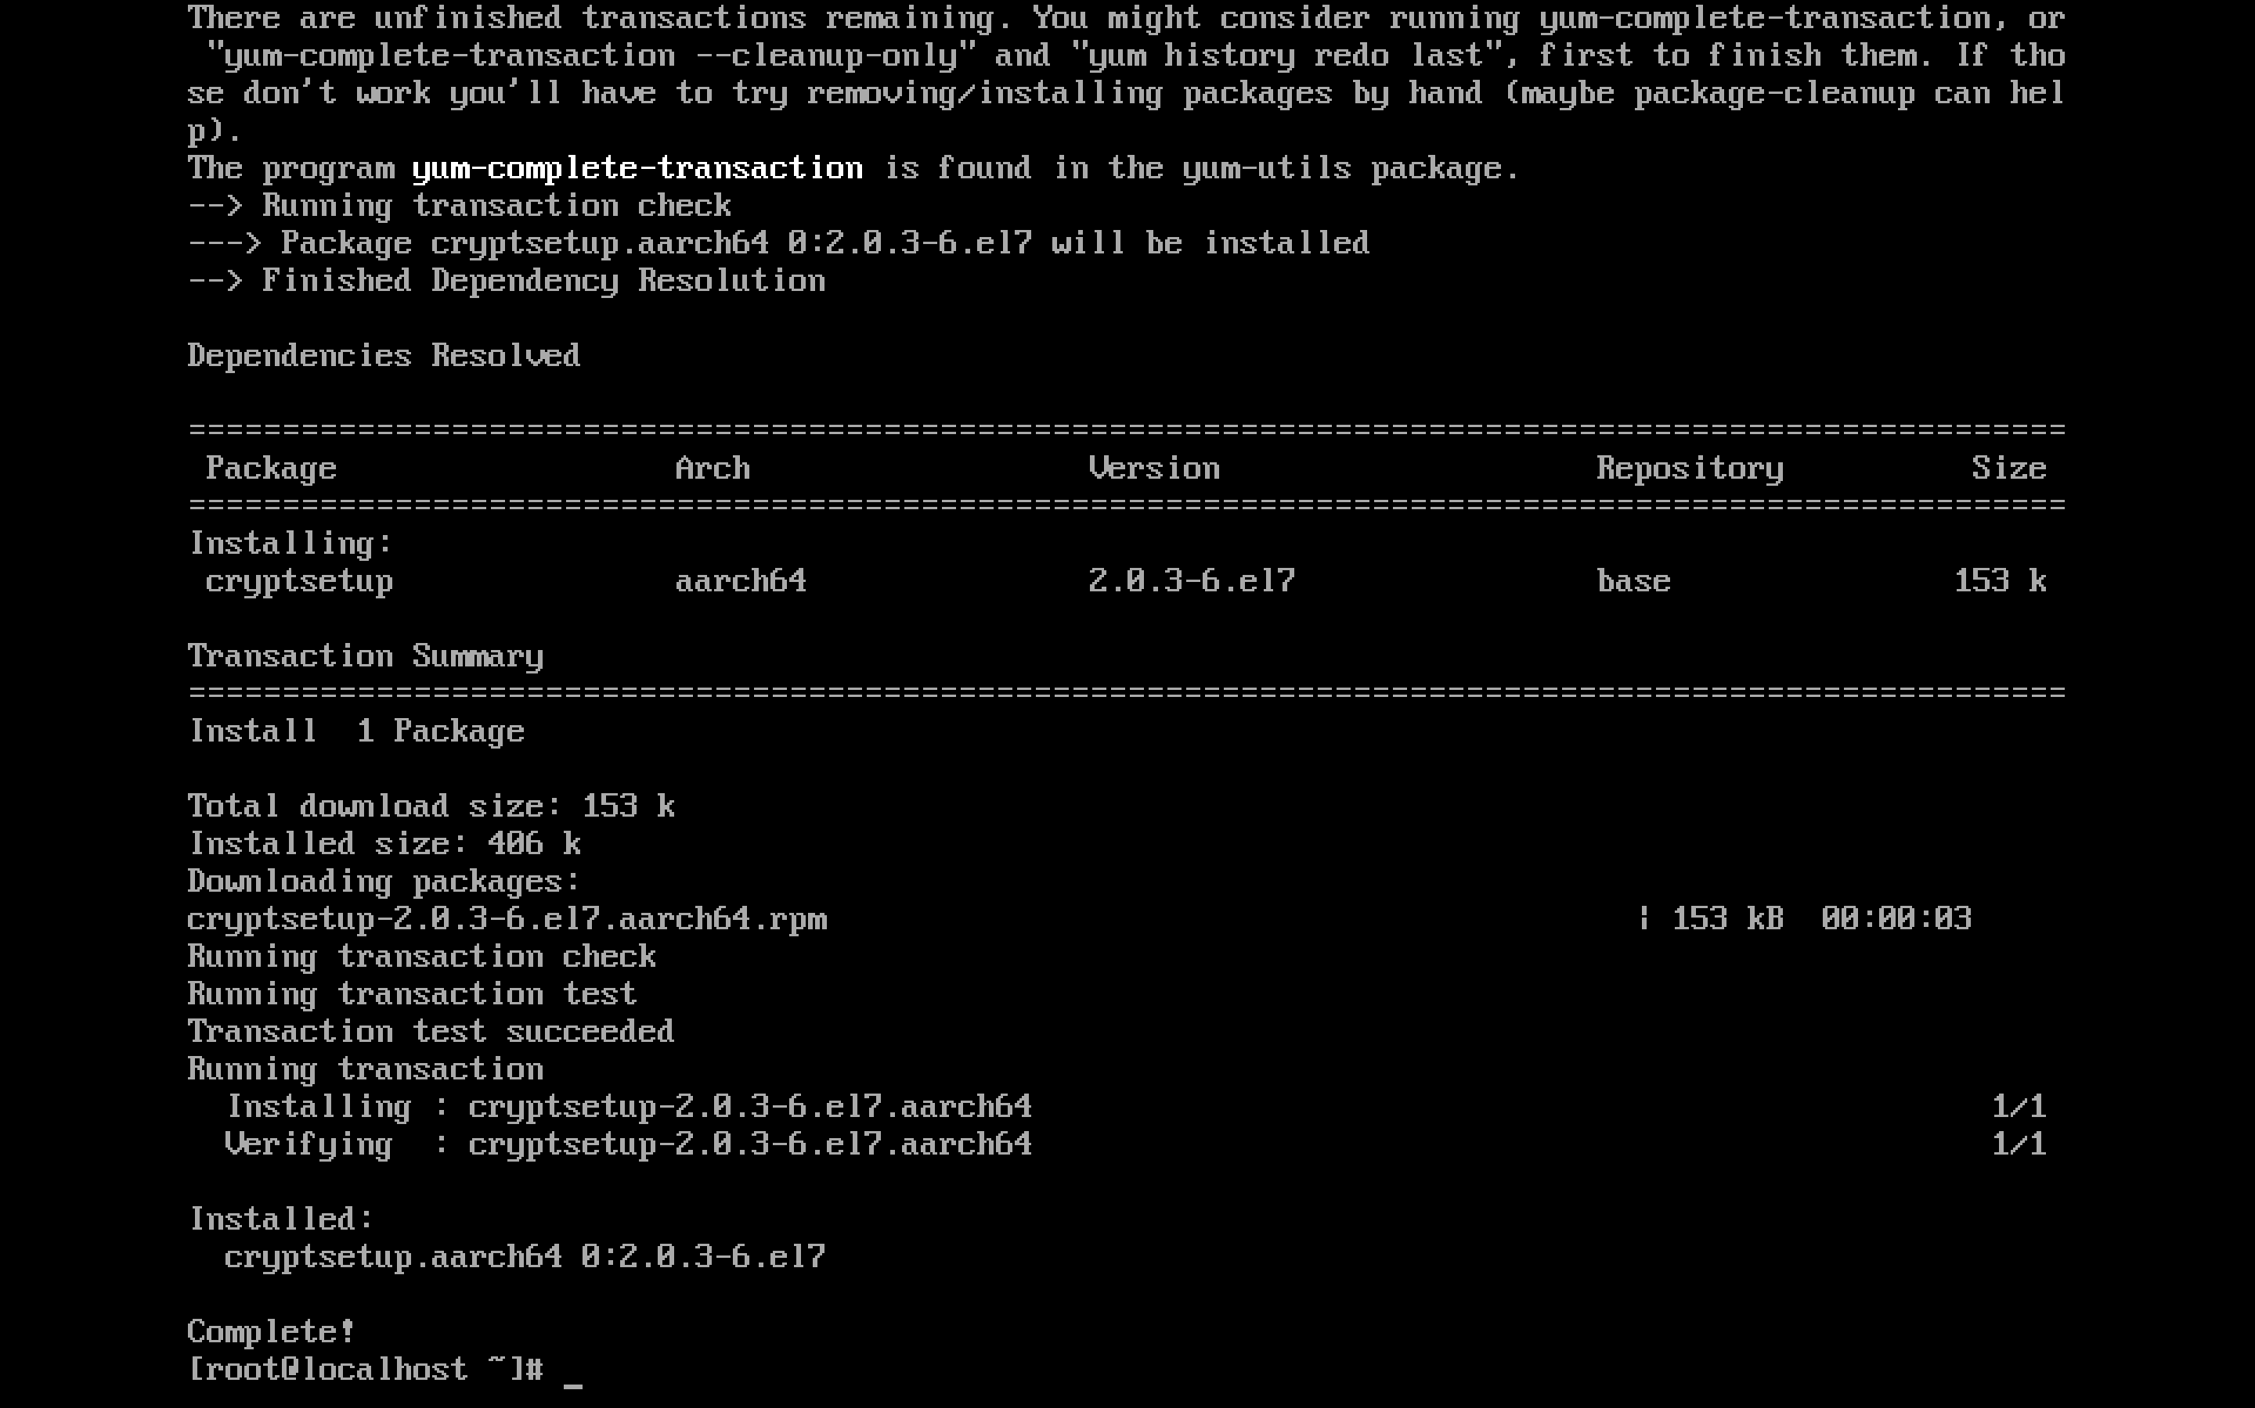

- Create a new partition or target to an existing partition.

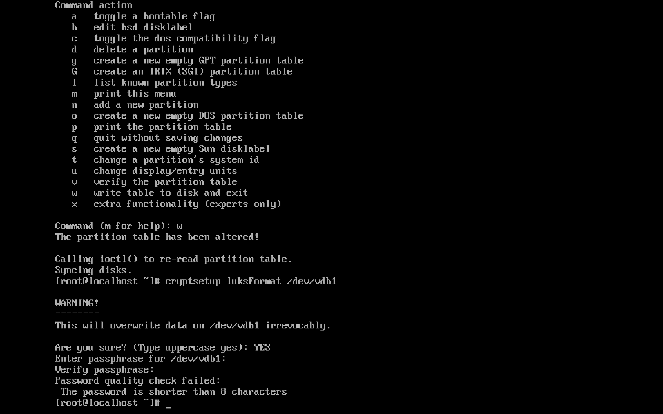

- Convert the partition to LUKS format

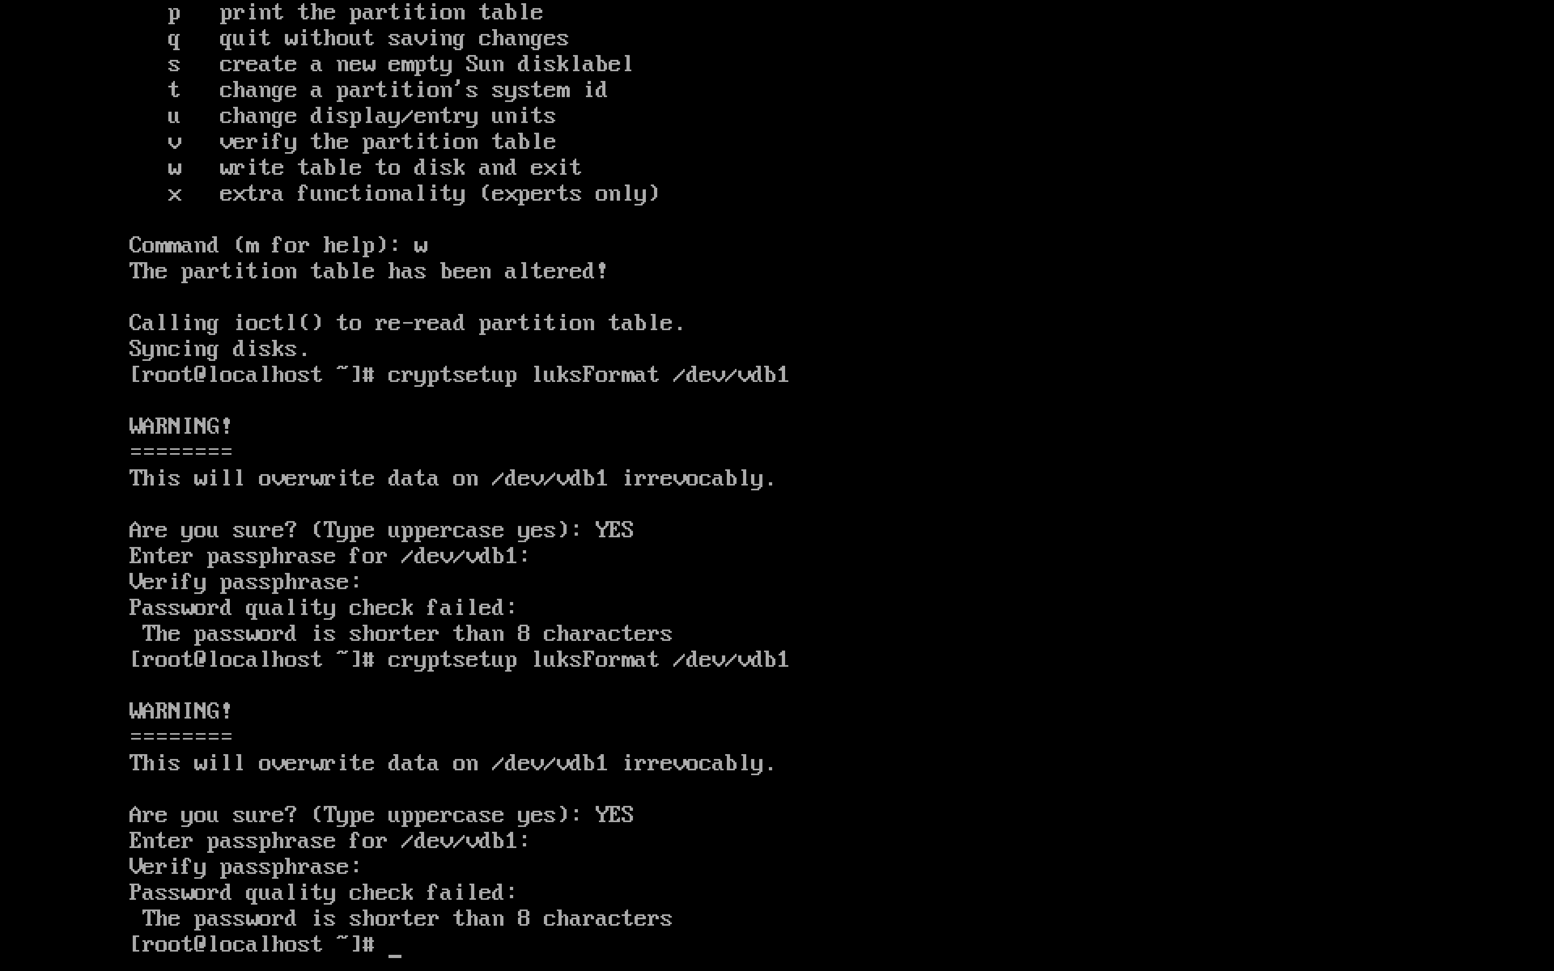

- Map the LUKS partition to a logical volume

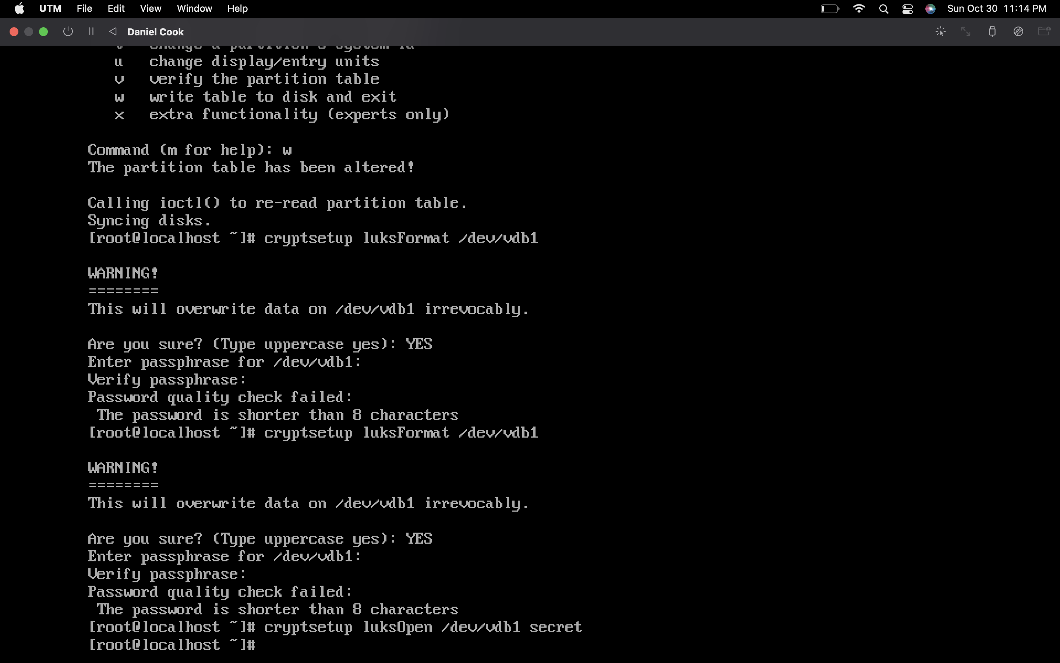

- Format the volume with a file system.

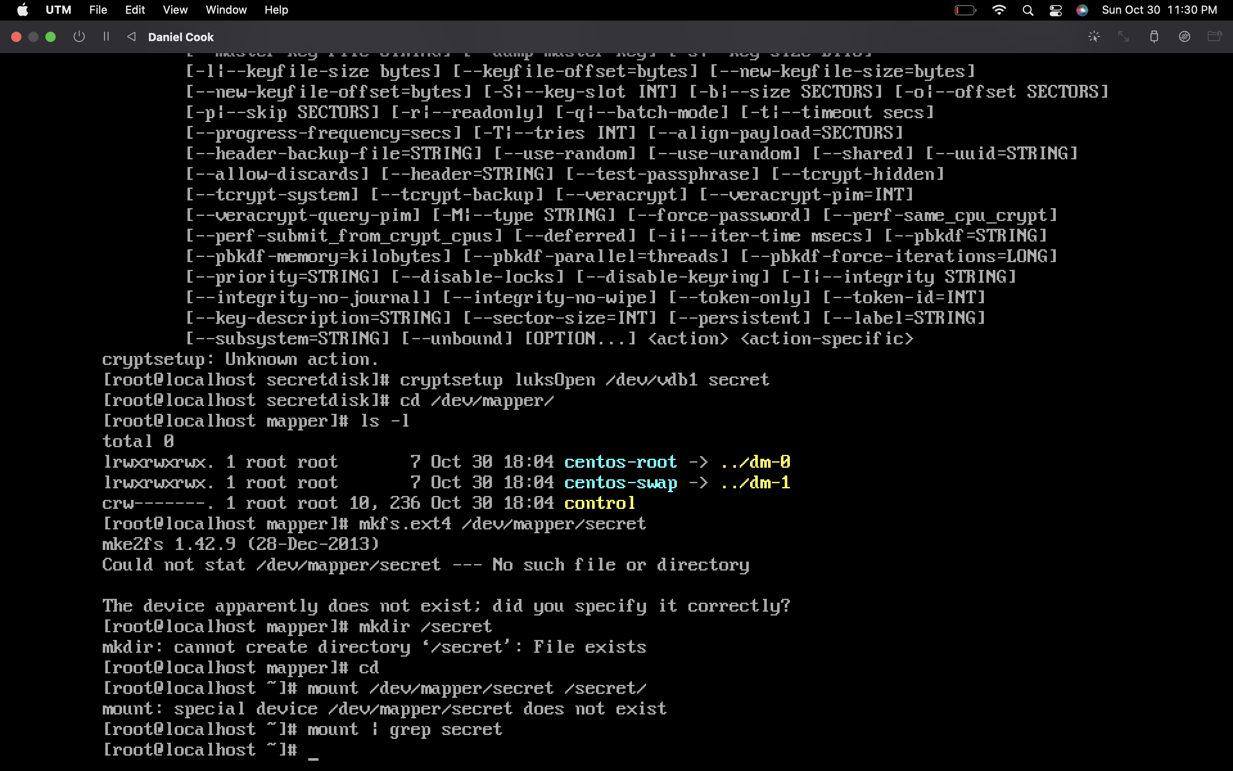

-Check the status of the encrypted disk.

